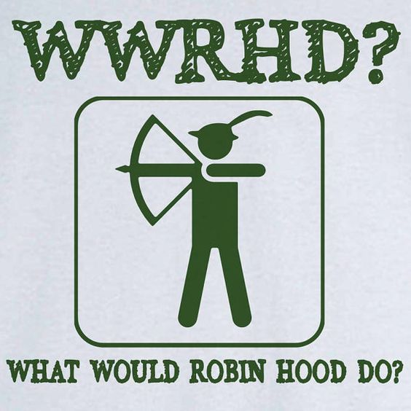
How Moral Are You?

To do this personality test you must give your opinion about the morals and honesty of the four characters in the story - Robin Hood (R), Maid Marion (M), Little John (L), and the Sheriff of Nottingham (S). Forget any memories you have about the characters in this story (e.g., forget that Robin Hood was a good guy in all of the stories). The story is as follows:

The Sheriff of Nottingham captured Little John and Robin Hood and imprisoned them in his maximum-security dungeon. Maid Marion begged the Sheriff for their release, pleading her love for Robin. The Sheriff agreed to release them only if Marion slept with him. She agreed.

The next morning, the Sheriff released the prisoners. Robin at once demanded that Marion tell him how she persuaded the Sheriff to let them free. When Marion confessed the truth, Robin abused her, calling her a prostitute and saying that he never wanted to see her again. She was bewildered.

At this, Little John defended her, inviting her to leave Sherwood Forest with him. He promised her lifelong devotion. Robin Hood was left alone, infuriated, as his ex-lover and ex-friend rode away together.

In terms of realistic everyday standards of behavior, put R, M, L, and S in the order in which you consider them to be moral and honest based on their behavior in the story. There is no “right” answer. Also, remember that answers will vary across cultural and societal backgrounds.

STOP! Do not tell anyone your answer to the following question! You might be embarrassed later if you do! Answer these questions in your mind.

Who do you think was the most moral? Who was the least? Why?
This activity is based on a test available at https://www.personalityquiz.net/relational/robinhood.html
Unless otherwise noted, this activity is copyright 2021 – Nelson Parish
WWRHD?: https://www.pinterest.co.kr/pin/370984088029457091/
Vocabulary for “How Moral Are You?”
Term | Definition
1. abuse (v.) | a. ___ by or of the culture and country one lives in
2. beg (v.) | b. ___ confused
3. bewildered (adj.) | c. ___ get someone to agree with you
4. confess (v.) | d. ___ giving no chance of getting in or out without permission
5. devotion (n.) | e. ___ loyalty
6. dungeon (n.) | f. ___ mistreat; be mean and unfair to someone
7. infuriated (adj.) | g. ___ a person’s ideas of what’s wrong or right
8. maximum-security (adj.) | h. ___ a person (usually a woman) who has sex for money or something else valuable
9. moral (adj.) | i. ___ plead; strongly ask for help or a favor
10. morals (n.) | j. ___ a slang term meaning “have sex with someone”
11. persuade (v.) | k. ___ something that most people consider normal
12. prostitute (n.) | l. ___ tell something that is unknown
13. sleep with someone (v. phrase) | m. ___ an underground place where prisoners are held
14. societal (adj.) | n. ___ valuing proper (good, kind, etc.) behavior
15. standard (n.) | o. ___ very angry
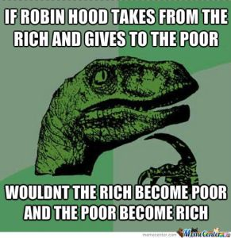
This page is copyright 2021 – Nelson Parish
Dinosaur: https://silenthumming.wordpress.com/tag/robin-hood/

This activity and answers are based on a test available at https://www.personalityquiz.net/relational/robinhood.html.
Unless otherwise noted, this activity is copyright 2021 – Nelson Parish
Questions
1. What are some good qualities of each of the characters in the story? Some bad qualities?
2. Do you agree with the assessment of your personality? Why or why not?
3. Do you think morality and honesty are the same? If not, how do they differ?
4. What is presentism? Do you think it’s fair to judge Robin Hood, who would have lived in the 1200s, by today’s moral standards? Why or why not?
5. What’s the difference between morals and ethics?
This activity and answers are based on a test available at https://www.personalityquiz.net/relational/robinhood.html.
Activity questions copyright 2021 – Nelson Parish
Robin Hood picture:
http://4.bp.blogspot.com/-GNo9iNNdSb8/T2uYQaTxnJI/AAAAAAAAhcg/pD2QW99lTf4/s1600/a%2Blouca%252C%2Blouca%2Bhist%25C3%25B3ria%2Bde%2Brobin%2Bhood.jpg

